
SRM Institute of Science and Technology
Mode of Exam
OFFLINE
SET A

College of Engineering and Technology
DEPARTMENT OF ECE
SRM Nagar, Kattankulathur – 603203, Chengalpattu District, Tamilnadu
Academic Year: 2022-2023 (ODD)
Test: CLAT- 1 Date: 08/09/2022 Duration: 60 Minutes
Course Code & Title: 18ECC203J - Microprocessor, Microcontroller and Interfacing Techniques Year & Sem: III / V Max. Marks: 25

Course Articulation Matrix :
 | 18ECC203J - Microprocessor, Microcontroller and Interfacing Techniques | Program Outcomes (POs)
 |  | Graduate Attributes |  |  |  |  |  |  |  |  |  |  |  |  | PSO
Cos | Course Outcomes (COs) | 1 | 2 | 3 | 4 | 5 | 6 | 7 | 8 | 9 | 10 | 11 | 12 | 1 |  | 2 | 3
CO-1 : | Apply a basic concept of digital fundamentals to Microprocessor based personal computer system | - | 2 | - | - | - | - | - | - | - | - | - | - | - |  | - | -
CO-2 : | Demonstrate programming proficiency using the various addressing modes of the 8086 microprocessor | - | 3 | - | - | 2 | - | - | - | - | - | - | 2 | - |  | - | -
CO-3 : | Develop interfacing techniques using various peripheral chips with microprocessor | - | 2 | 3 | - | 3 | - | - | - | - | - | - | - | - |  | - | 1
CO-4 : | Evaluate programming proficiency using the various addressing modes of the 8051 microcontroller | - | 3 | - | - | 2 | - | - | - | - | - | - | 2 | - |  | - | -
CO-5 : | Construct a system to interface various peripheral chips with microcontroller | - | 2 | 3 | - | 3 | - | - | - | - | - | - | - | - |  | - | 3
CO-6 : | Implement the practical knowledge through laboratory experiments using microprocessor and microcontroller | - | - | 3 | - | 3 | - | - | - | - | - | - | 2 | 1 |  | - | 2

Part – A (5x1 = 5 Marks)
Answer all the questions
Q. No | Question | Marks | BL | CO | PO
 | How many 16-bit Segment Registers does 8086 have?  - 4  - 8  - 2  - 6 | 1 | 1 | 1 | 2
 | Which of the following address lines in an 8086 microprocessor are multiplexed with status signals?  - A19 – A15  - A19 – A16  - A14 – A11  - A3 – A0 | 1 | 2 | 1 | 2
 | If the microprocessor has 10 address lines, then the number of memory locations it is able to address is  A. 512  B. 1024  C. 2048  D. 20480 | 1 | 3 | 1 | 2
 | A ____________translates instructions fetched from memory into a series of actions which the EU carries out  A. Control circuitry  B. Instruction Decoder  C. ALU  D. Flag register | 1 | 2 | 1 | 2
 | ___________ status signal is always low  A. S3  B. S4  C. S5  D. S6 | 1 | 1 | 1 | 2
Part – B (2 x 10 = 20 Marks)
Instructions: Answer ANY 2 Questions
6 | With neat diagram explain the architecture of 8086 microprocessor.  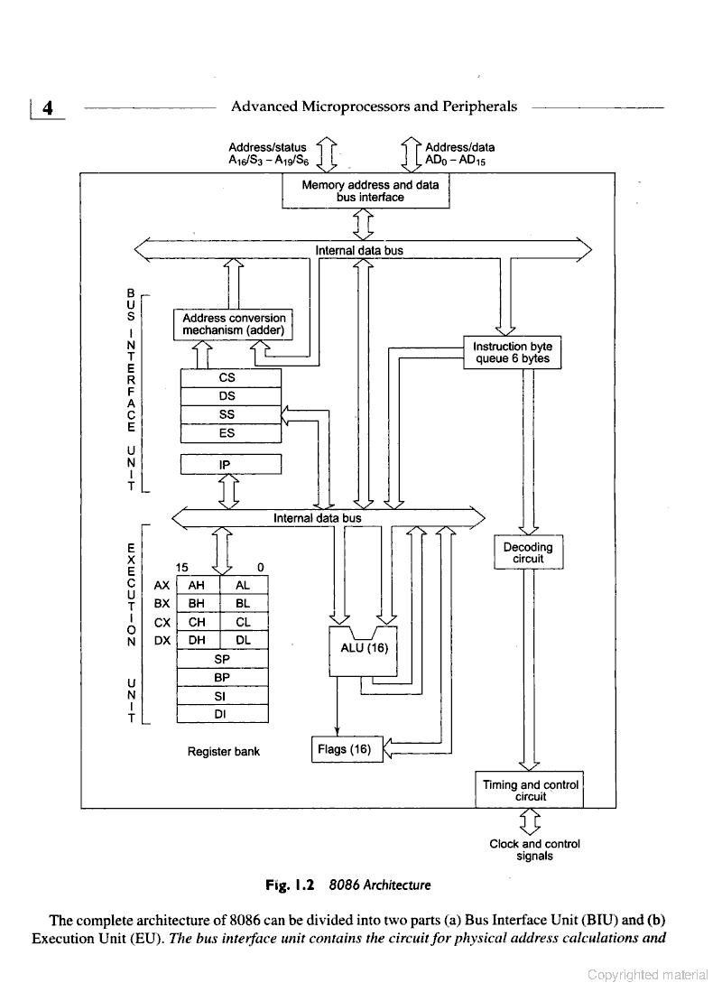  The complete architecture is divided into two parts:  - Bus Interface Unit  - Execution Unit  BIU: It sends out addresses, fetches instructions from memory, reads data from ports and memory and writes data to ports and memory.  EU: It tells the BIU where to fetch instructions or data from, decodes instructions and executes instructions | 10 | 2 | 1 | 2
7 | Describe the functional blocks of minimum mode system using 8086 microprocessor with memory write timing diagram.  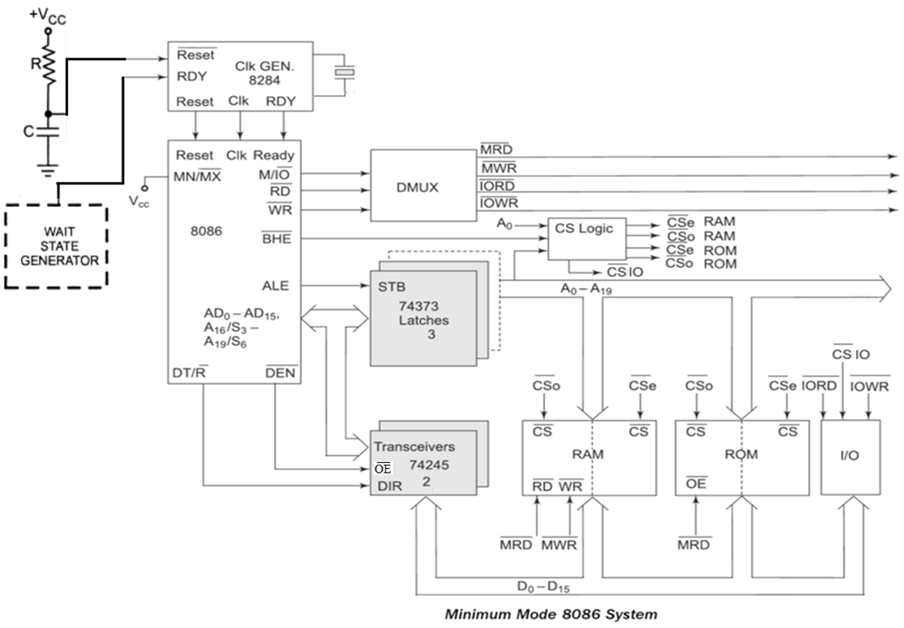  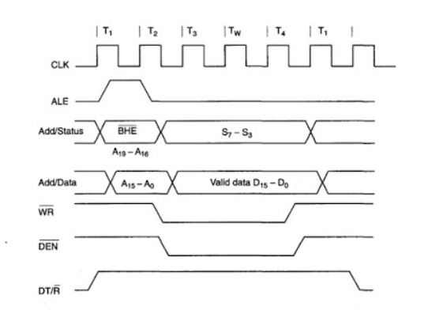 | 10 | 3 | 1 | 2
8 | - Distinguish between 8086 microprocessor and 8088 microprocessor.  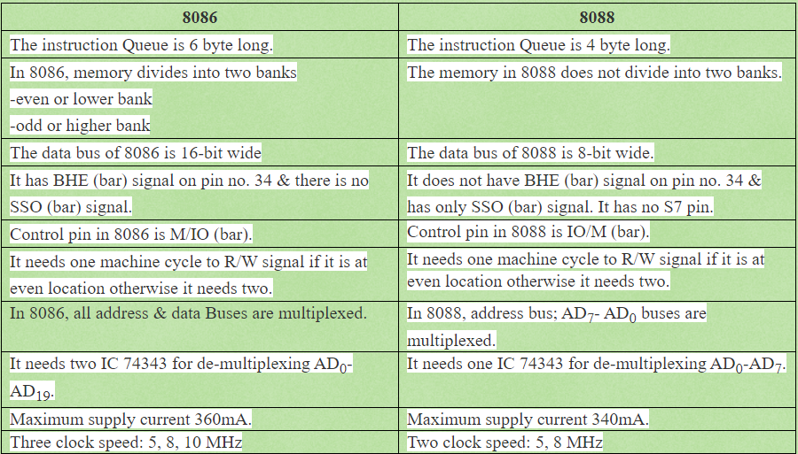  - Examine the signals that are specific to maximum mode operation.  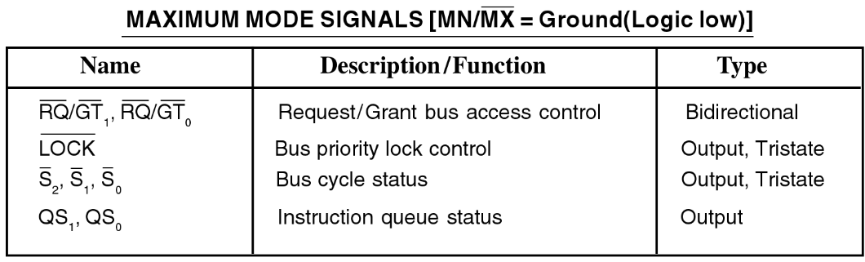  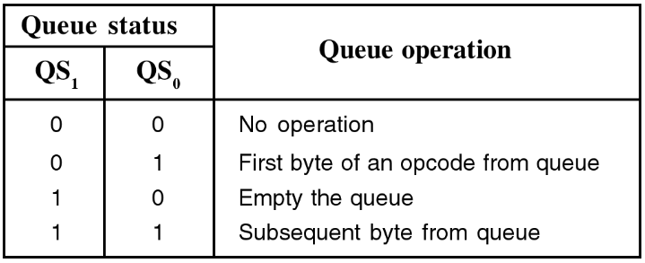  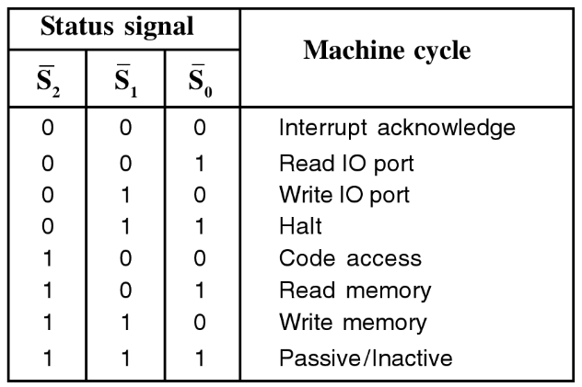 | 5+5 | 4 | 1 | 2

Course Outcome (CO) and Bloom’s level (BL) Coverage in Questions
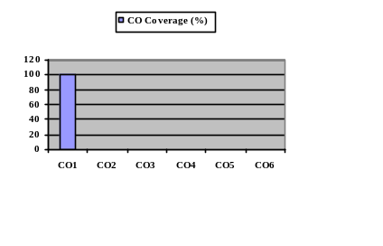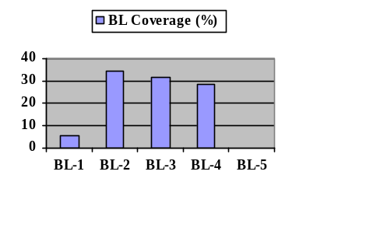

Approved by the Course Coordinator Signature of the Question paper setter

Evaluation Sheet
Name of the Student: Register No.:

Part- A (5 x 1= 5 Marks)
Q. No | CO | PO | Maximum Marks | Marks Obtained | Total
1 | 1 | 2 | 1
2 | 1 | 2 | 1
3 | 1 | 2 | 1
4 | 1 | 2 | 1
5 | 1 | 2 | 1
Part- B (2 x 10= 20 Marks)
11 | 1 | 2 | 10
12 | 1 | 2 | 10
13 | 1 | 2 | 10

Consolidated Marks:

CO | Maximum Marks | Marks Obtained
1 | 25
Total

PO | Maximum Marks | Marks Obtained
2 | 25
Total

Signature of Course Teacher

Signature of the Course Coordinator Signature of the Academic Advisor

